**LAB REPORT NO 8**



Submitted by:  **Muhammad Ali**

Registration No: - **19PWCSE1801**

Class Section: A

“On my honor, as student of University of Engineering and Technology, I have neither given nor received unauthorized assistance on this academic work.”

Submitted to:

**Engr. Durr-e-Nayab**

Data:(08,07,2021)

Department of Computer Systems Engineering

University of Engineering and Technology, Peshawar

**Task no 1: -**

clc

clear all

close all

t= -2:1/10:10;

x1 = sin(0.8*pi*2*t);

subplot(3,1,1);

stem(t,x1,'LineWidth',2);

title('discret time 10 sample per sec');

u = (t>=0);

x2 = x1.*u;

subplot(3,1,2);

stem(t,u, 'r','LineWidth',2);

title('Unit Step');

subplot(3,1,3);

stem(t,x2, 'k','LineWidth',2);

title('resultant singal causal version');

axis([-3 3 -1.5 1.5]);

**Output: -**

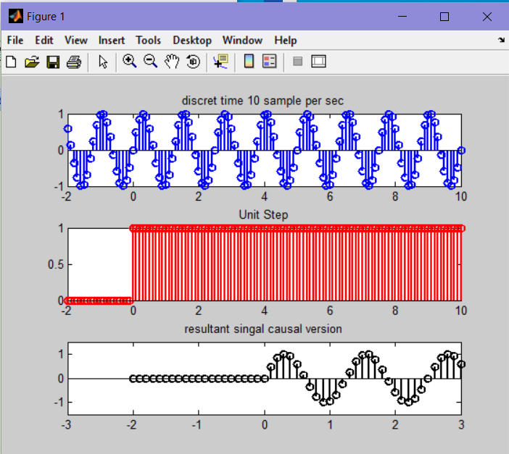

**Task no 2: -**

clc

clear all

close all

t= -5:1/1000:5;

x1 = sin(2*pi*2*t);

subplot(3,1,1);

plot(t,x1,'LineWidth',2);

title('sin(2*\pi*f*t)');

u = (t<0);

x2 = x1.*u;

subplot(3,1,2);

plot(t,u, 'r','LineWidth',2);

title('Unit Step');

subplot(3,1,3);

plot(t,x2, 'k','LineWidth',2);

title('anti-causal version of sin(2*\pi*f*t)');

figure;

plot(t,x1,t,u,t,x2,'LineWidth',2);

text(0,1.2,'unit signal u(t)','FontSize',16);

text(-3.2,-1.1,'anti causal signal x(t)','FontSize',16);

text(0.8,-1.1,' causal x(t)*u(t)','FontSize',16);

axis([-5 5 -1.5 1.5]);

**Output: -**

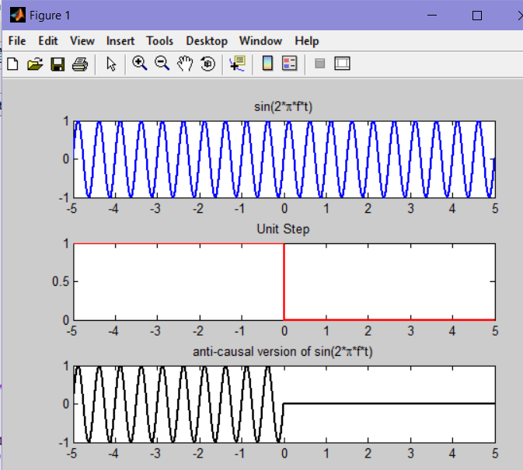

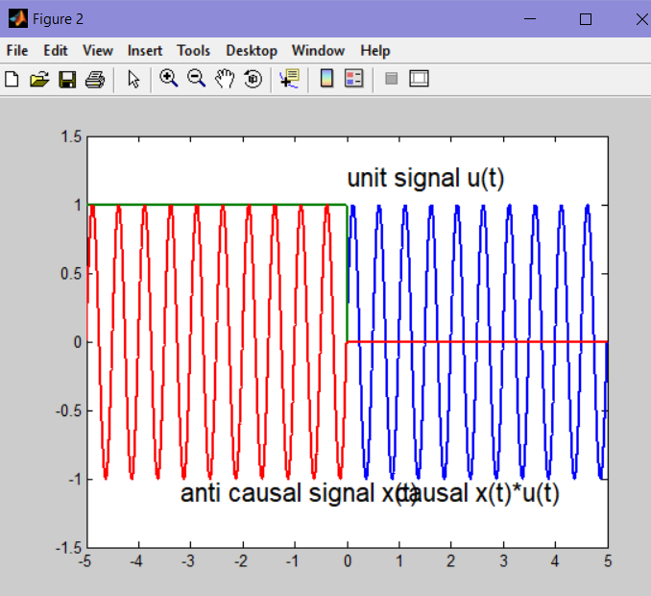

**Task no 3: -**

clc

clear all

close all

t=-10:1:10;

sign=sin(0.2*t);

position=(t>=0);

x1=sign.*position;

sig_causal(sign,position,x1,t)

function sig_causal(s,p,x,t)

subplot(3,1,1);

stem(t,s);

subplot(3,1,2);

stem(t,p);

subplot(3,1,3);

stem(t,x);

**Output: -**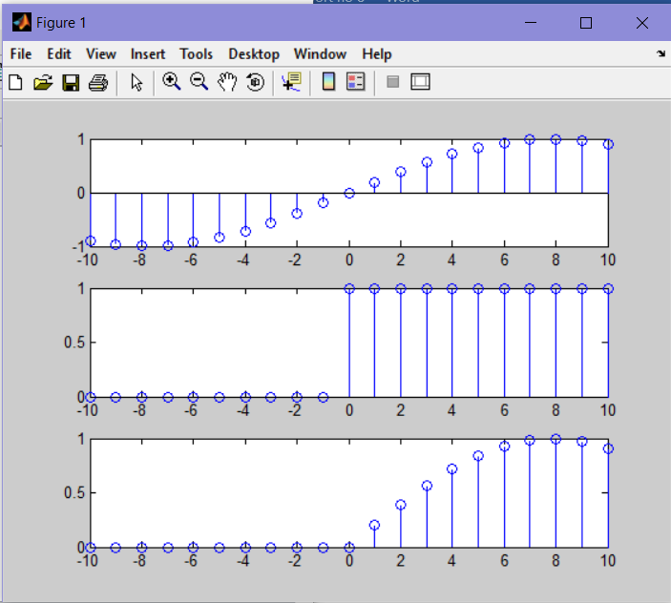

**Task no 4: -**

clc

clear all

close all

t=-10:1:10;

x=[2 4 6 4 2];

h=[3 -1 2 1];

y=conv(x,h);

subplot(2,1,1);

stem(x);

title('Discrete Input x');

xlabel('index, n');

subplot(2,1,2);

stem(y);

title('Discrete convolution output y');

xlabel('index, n');

**Output: -**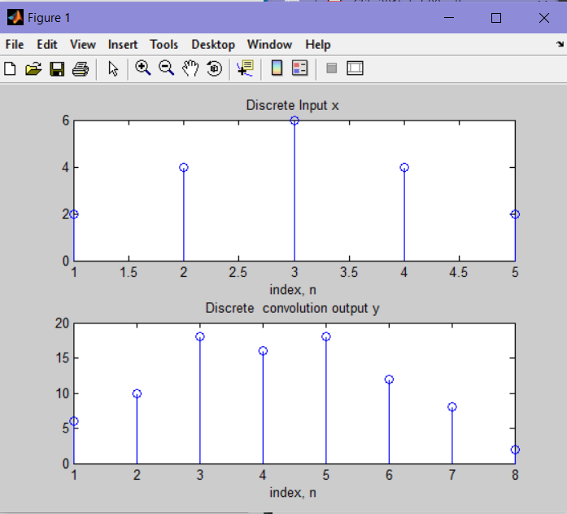

**Task no 5: -**

clc

clear all

close all

x1=[3 1 1];

x2=[4 2 1];

x3=[3 2 1];

lhs=(x1.*x2).*x3;

rhs=x1.*(x2.*x3);

subplot(2,1,1);

stem(lhs);

title('left side of associative convolution formula');

xlabel('index, n');

axis([0 4 0 40]);

subplot(2,1,2);

stem(rhs);

title('Right side of associative convolution formula');

xlabel('index, n');

axis([0 4 0 40]);

**Output: -**

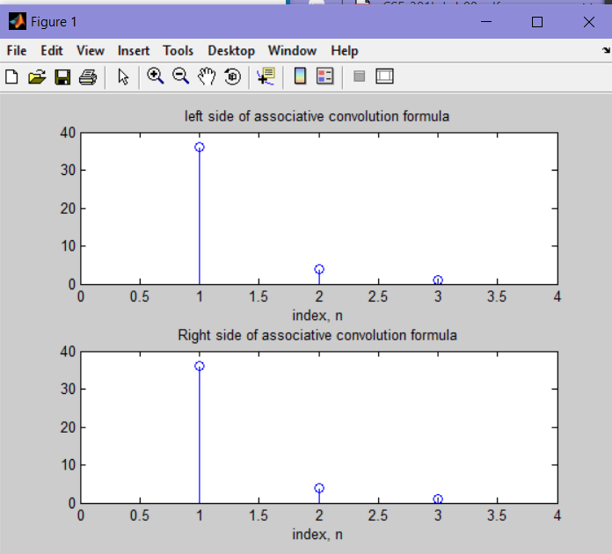

**Task no 6: -**

clc

clear all

close all

x=[2 3 4 1];

h=[3 4 2 1 2];

y=conv(x,h);

subplot(2,1,1);

stem(x);

title('input x');

xlabel('index, n');

axis([-4 8 0 5]);

subplot(2,1,2);

stem(y);

title('convolution of x');

xlabel('index, n');

axis([-4 10 -2 30]);

**Output: -**

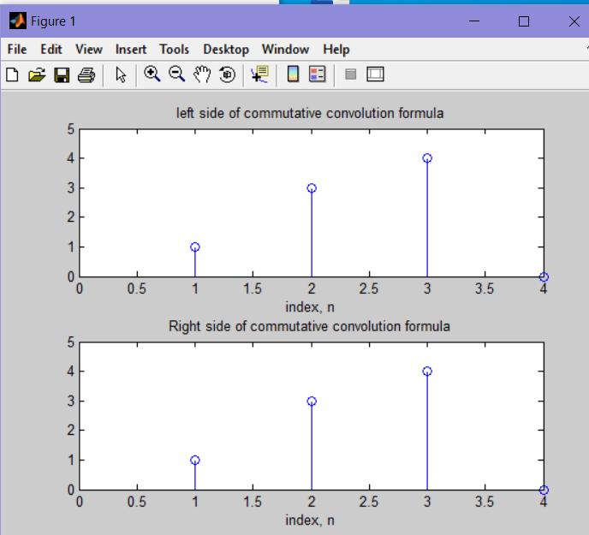

**Task no 7: -**

clc

clear all

close all

x=[2 3 4 1];

h=[3 4 2 1 2];

y=conv(x,h);

subplot(2,1,1);

stem(x);

title('input x');

xlabel('index, n');

axis([-4 8 0 5]);

subplot(2,1,2);

stem(y);

title('convolution of x');

xlabel('index, n');

axis([-4 10 -2 30]);

**Output: -**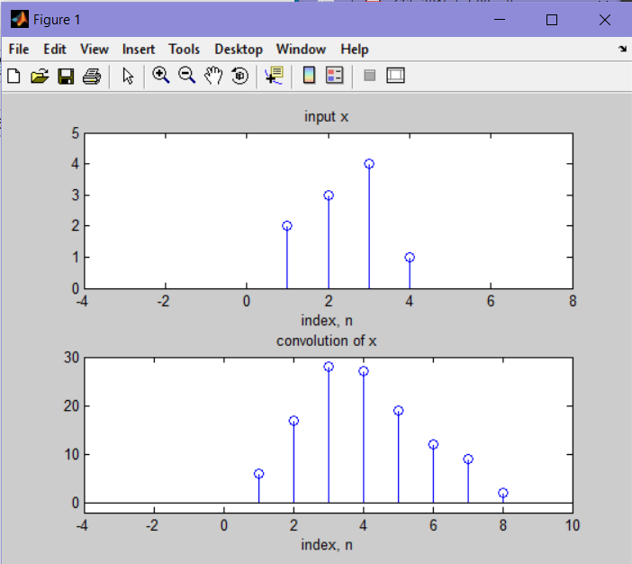

**Task no 8: -**

clc

clear all

close all

x=[2 3 4 1];

h1=[1 3 2 1];

h2=[1 1 2];

y1=conv(x,h1);

y2=conv(y1,h2);

subplot(3,1,1);

stem(x);

title('input x');

xlabel('index, n');

axis([-4 8 0 5]);

subplot(3,1,2);

stem(y1);

title('convolution of x[n] by first system as y1[n]');

xlabel('index, n');

axis([-4 10 -5 30]);

subplot(3,1,3);

stem(y2);

title('convolution of x[n] by both systems as y[n]');

xlabel('index, n');

axis([-4 10 -5 80]);

**Output: -**

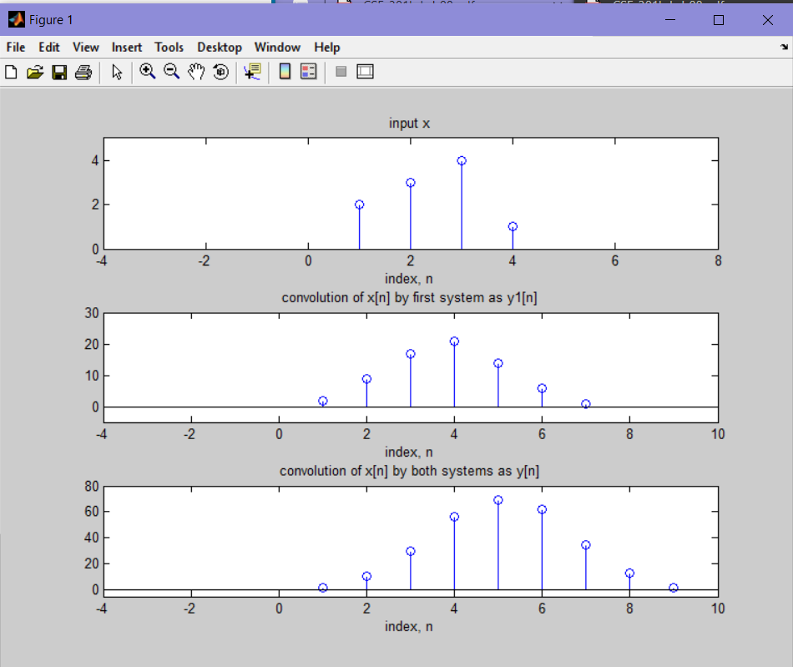

**Task no 9: -**

clc

clear all

close all

x1=[-2 4 3 -3 2];

x2=[-2 -1 3 2 4];

x3=[0 4 -3 5 3];

lhs=(x1.*x2).*x3;

rhs=x1.*(x2.*x3);

subplot(3,1,1);

stem(x1);

title('x1[n]');

xlabel('index, n');

subplot(3,1,2);

stem(x2);

title('x2[n]');

xlabel('index, n');

subplot(3,1,3);

stem(x3);

title('x3[n]');

xlabel('index, n');

figure;

subplot(2,1,1);

stem(lhs);

title('x1[n] * (x2[n] * x3[n])');

xlabel('index, n');

axis([-5 10 -40 40]);

subplot(2,1,2);

stem(rhs);

title('(x1[n] * x2[n]) * x3[n] ');

xlabel('index, n');

axis([-5 10 -40 40]);

figure;

lhs=x1.*x2;

rhs=x2.*x1;

subplot(2,1,1);

stem(lhs);

title('x1[n] * x2[n]');

xlabel('index, n');

axis([-4 10 -10 10]);

subplot(2,1,2);

stem(rhs);

title('x2[n] * x1[n]');

xlabel('index, n');

axis([-4 10 -10 10]);

**Output: -**

